**Lab Exercise 5 – Terraform Variables with Command**

**Line Arguments**

**Objective:**

**Learn how to pass values to Terraform variables using command line arguments.**

**Prerequisites:**

**• Terraform installed on your machine.**

**• Basic knowledge of Terraform variables.**

**Steps:**

1. **Create a Terraform Directory**

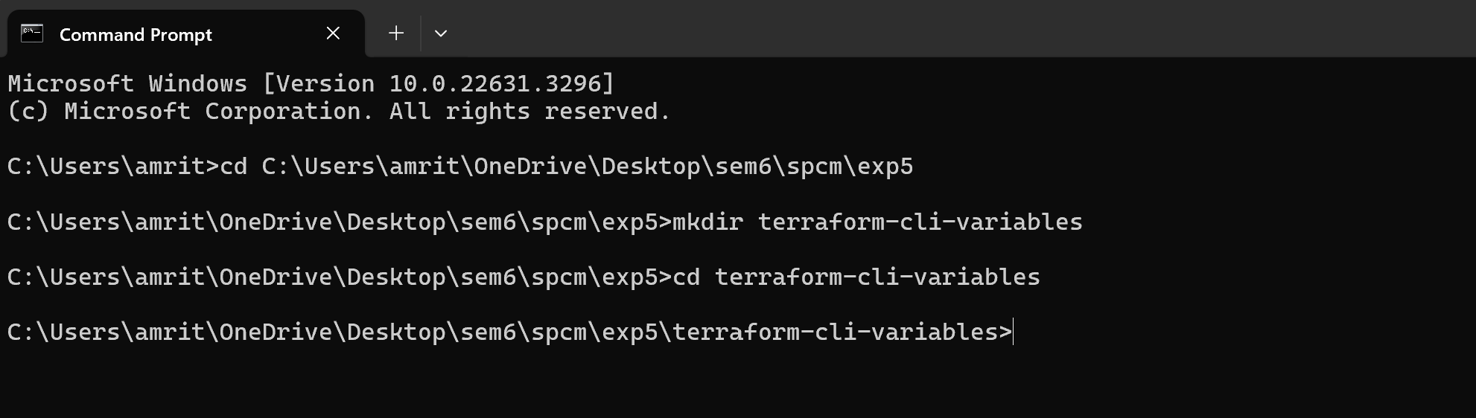

**2. Create Terraform Configuration Files:**

**• Create a file named main.tf:**

**# main.tf**

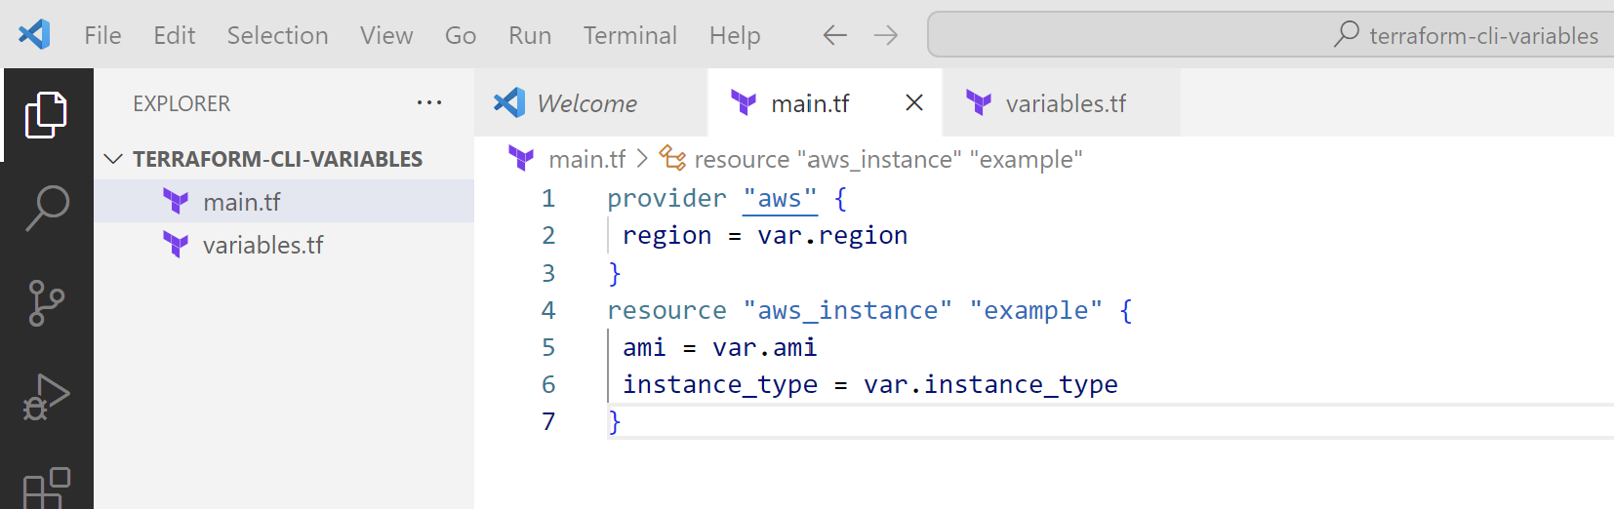

**• Create a file named variables.tf:**

**# variables.tf**

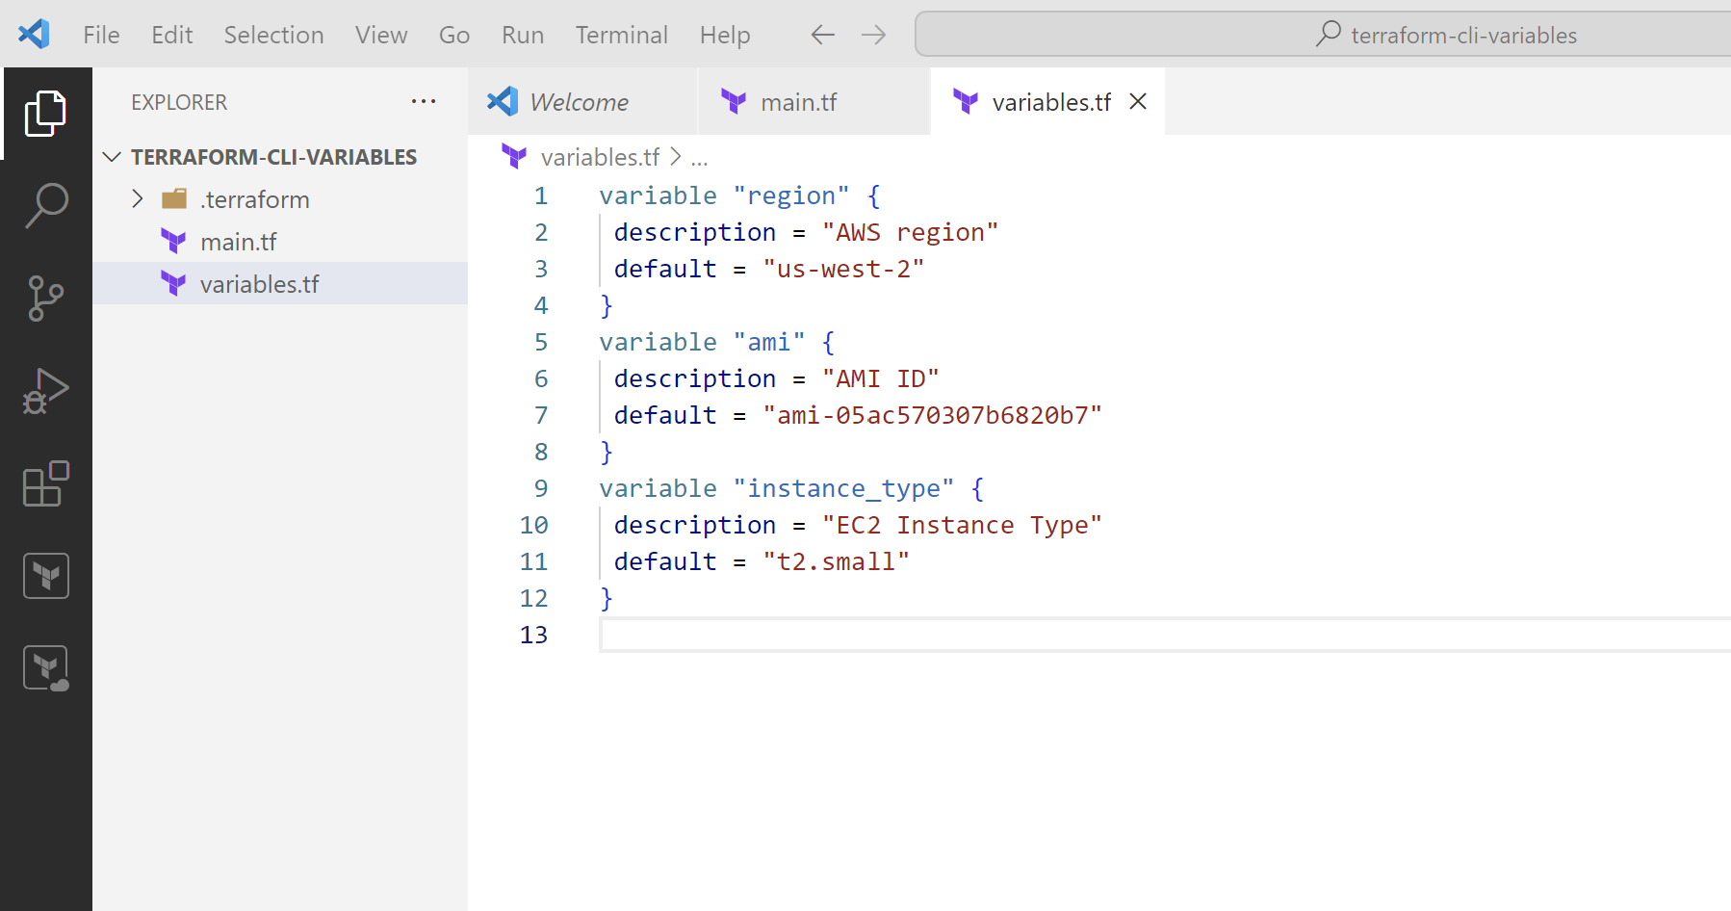

**3. Use Command Line Arguments:**

**• Open a terminal and navigate to your Terraform project directory.**

**• Run the terraform init command:**

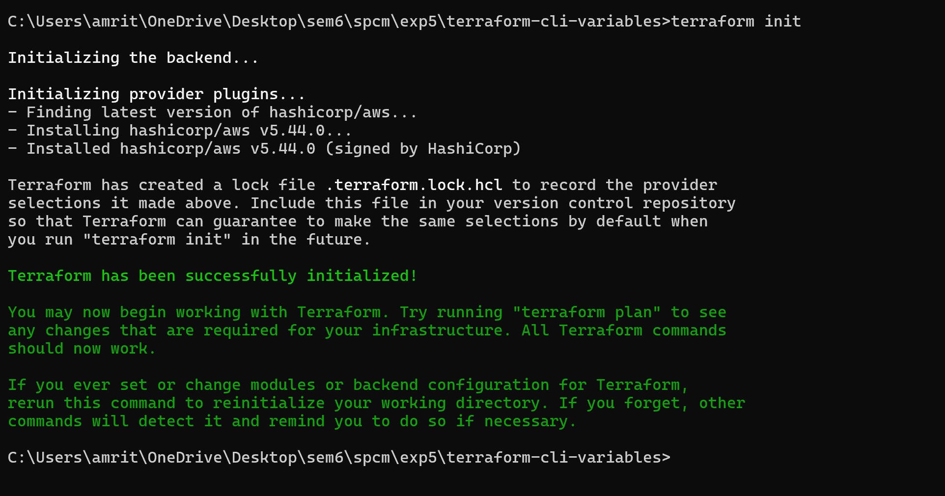

**terraform apply -var 'region=us-east-1' -var 'ami=ami-12345678' -var 'instance_type=t2.micro**



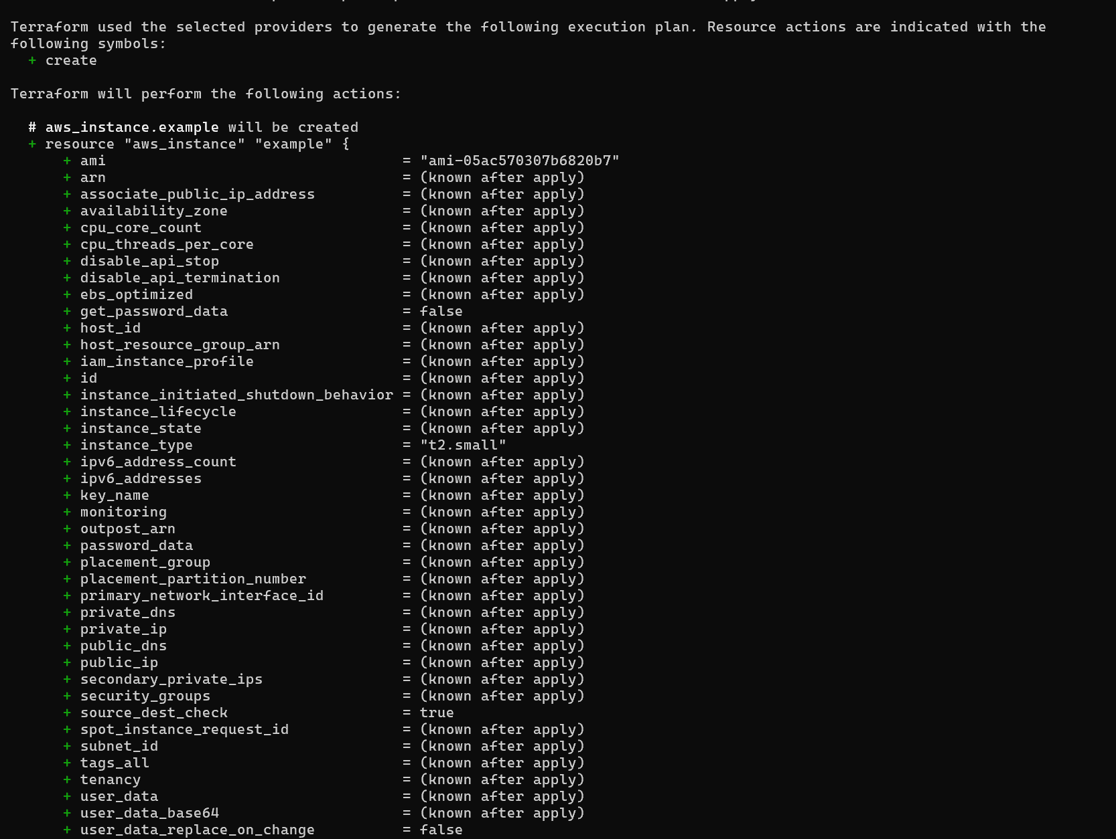

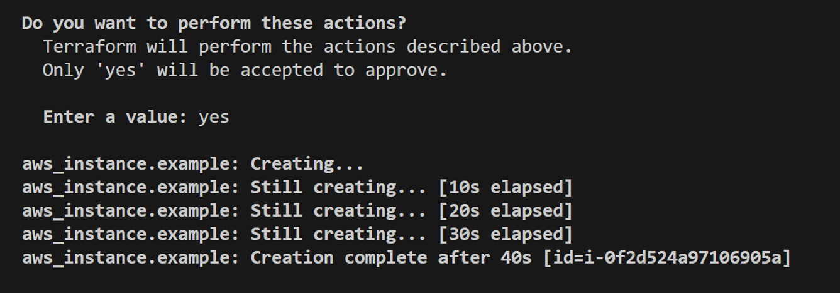

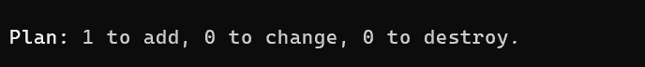

**4.Test and Verify:**

**• Observe how the command line arguments dynamically set the variable values**

**during the apply process.**

**• Access the AWS Management Console or use the AWS CLI to verify the creation**

**of resources in the specified region.**



**5. Clean Up:**

**After testing, you can clean up resources:**

**terraform destroy**

**Confirm the destruction by typing yes.**

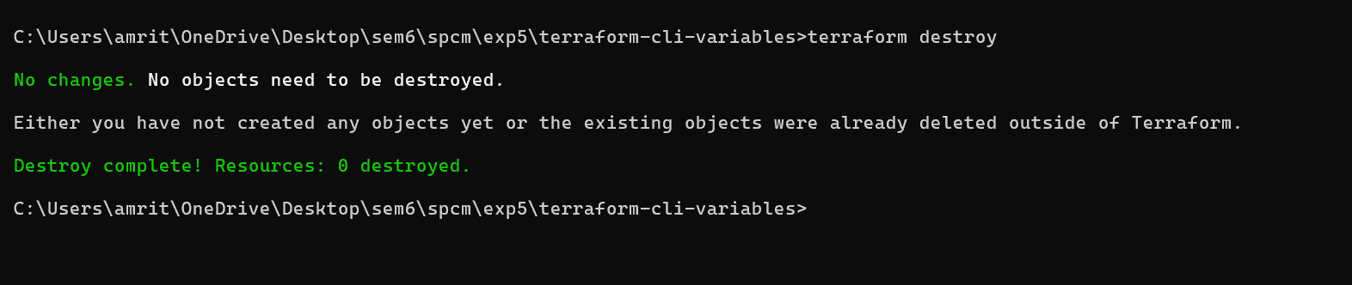

**6. Conclusion:**

**This lab exercise demonstrates how to use command line arguments to set variable**

**values dynamically during the terraform apply process. It allows you to customize your**

**Terraform deployments without modifying the configuration files directly.**

**Experiment with different variable values and observe how command line arguments**

**impact the infrastructure provisioning process.**